Dear Parents,
Would you like to find simple, fun ways to help your child be more successful in school? Imagine spending quality time together while strengthening important skills!
Research shows that when families are actively involved in a child’s education, students are more likely to earn higher grades, attend school regularly, take on more challenging coursework, and demonstrate positive behavior. However, we know it’s not always easy to find meaningful ways to help at home — and that’s where Connected Class Learning Link videos come in!
Throughout the year, I’ll be sending short Learning Link videos focused on literacy and mathematics.
- Some videos will show easy, hands-on games using everyday items like cards, dominoes, or dice to practice math concepts.
- Others will introduce engaging literacy activities that motivate students to read nightly and strengthen key reading skills.
Each video includes:
- A clear explanation of the skill or concept being taught
- Step-by-step instructions and examples
- Tips to adjust the activity for your child’s specific level
- An activity card you can print or save for quick reference
If you notice your child needs extra support in a certain area, please let me know, and I can share additional Learning Link videos to provide extra practice.
You’ll receive Learning Link emails directly from support@connectedclass.com. If you don’t see them in your inbox, please check your spam or junk folder. (I’ve attached a short guide to help with this.) If you still don’t receive the email, let me know — or you can contact Connected Class directly at support@connectedclass.com.
Please don’t hesitate to reach out if you have any questions. I’m excited to partner with you in helping your child grow and succeed this year!
Sincerely,
[Your Name]
[Your Title]

Having Problems Receiving Emails?
Follow these steps based on your email provider. If you are still not receiving emails from your child’s teacher after following these steps, please contact our team at support@connectedclass.com for help.

If your email provider is gmail:
 | Check your Spam folder:  Often emails from a location that your provider is not familiar with will end up in Spam.  Check your Promotions folder:  Gmail may think that Learning Link is a promotion.  Move to Inbox:  If you have found the emails in either Spam or Promotions, you can move them to your inbox by choosing “Not Spam” or “Not Promotions” once you have opened that folder. See picture below.  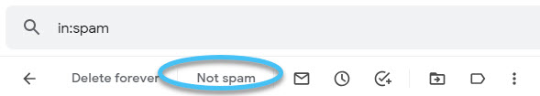 |  |  | To allow future emails from your child’s teacher to go right into your inbox:  - In your Google email account, choose settings (small gear at the top of your email).  - Choose “See all settings”.  - Choose “Filters and Blocked Addresses”.  - Click on “Create a new filter”.  - Enter the teachers email in the “From” section.  - Click on “Create filter”.  - Choose “Never send it to Spam” and choose “Categorize as: Primary”.  - Click on Create filter one last time. The filter has been created and the teachers’ emails should always go to your inbox.

If your email provider is (microsoft) outlook/msn/hotmail/live:
 | Check your Junk folder:  Often emails from a location that your provider is not familiar with will end up in Junk.  Move to Inbox:  If you have found the emails in your Junk folder, you can move them to your inbox by choosing “Not Junk” once you have opened that folder. See picture below.  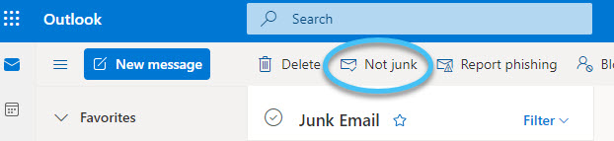 |  |  | To allow future emails from your child’s teacher to go right into your inbox:  - In your Microsoft/Outlook email account, choose settings (small gear at the top of your email).  - Click on “View all Outlook settings” found at the bottom of settings menu.  - Choose “Mail” in the first column.  - Choose “Rules” in the second column.  - Choose “Add new rule”.  - Choose “Name your rule” (this can be any name example: Not Junk).  - Add a condition, choose “From” and then type the teachers email in the box to the right of “From”.  - Add an action, choose “Move to”, choose “Inbox” in the box to the right of “Move to”.  - Click “Save”.

