Dear Parents/Guardians,
Gaining a deep understanding of fractions and mastering basic operations with fractions is important for success in higher-level mathematics. If students know how to work with fractions quickly and easily, they are less likely to get lost as math problems become more complex. Our class is participating in the Take Fraction Action Challenge by Connected Class, and we would love your help.
Your student will learn one new game each week to support them in the area they need to focus on. Each week, you'll receive an email containing a video that teaches a game to support and improve your child’s math skills. Aim to play for at least ten minutes, three times a week.
Please check your spam/junk folder if you do not see the Learning Link email listing my name from support@connectedclass.com. See attached guidelines for help with this. If you still do not receive an email, let me know. You may also reach out directly to the team at Connected Class for help at support@connectedclass.com.
A Parent Log will be sent home as well to record the number of times you play the game. This sheet should be signed and returned to school at the end of the challenge. Students will be given a pretest and a posttest to see how they have improved.
For this challenge, you will need a deck of cards. If you do not have any at home, they can be purchased at a dollar store near you or on Amazon.
Your child will be participating in the challenge circled below.
Finding Multiples Common Denominators 3rd Grade Fraction Review
Adding Fractions Subtracting Fractions All Things Fractions
Adding and Subtracting Fractions Multiplying and Dividing Fractions

Thank you for partnering with me to make math fun and exciting for your child!

Having Problems Receiving Emails?
Follow these steps based on your email provider. If you are still not receiving emails from your child’s teacher after following these steps, please contact Nicole at nicole@connectedclass.com for help.
IF YOUR EMAIL PROVIDER IS GMAIL:
 | Check your Spam folder:  Often emails from a location that your provider is not familiar with will end up in Spam.  Check your Promotions folder:  Gmail may think that Learning Link is a promotion.  Move to Inbox:  If you have found the emails in either Spam or Promotions, you can move them to your inbox by choosing “Not Spam” or “Not Promotions” once you have opened that folder. See picture below.  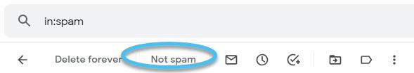 |  |  | To allow future emails from your child’s teacher to go right into your inbox:  - In your Google email account, choose settings (small gear at the top of your email).  - Choose “See all settings”.  - Choose “Filters and Blocked Addresses”.  - Click on “Create a new filter”.  - Enter the teachers email in the “From” section.  - Click on “Create filter”.  - Choose “Never send it to Spam” and choose “Categorize as: Primary”.  - Click on Create filter one last time. The filter has been created and the teachers’ emails should always go to your inbox.
IF YOUR EMAIL PROVIDER IS (MICROSOFT) OUTLOOK/MSN/HOTMAIL/LIVE:
 | Check your Junk folder:  Often emails from a location that your provider is not familiar with will end up in Junk.  Move to Inbox:  If you have found the emails in your Junk folder, you can move them to your inbox by choosing “Not Junk” once you have opened that folder. See picture below.  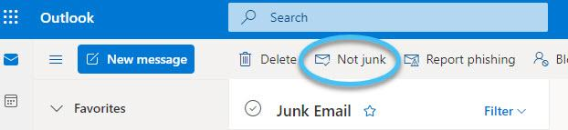 |  |  | To allow future emails from your child’s teacher to go right into your inbox:  - In your Microsoft/Outlook email account, choose settings (small gear at the top of your email).  - Click on “View all Outlook settings” found at the bottom of settings menu.  - Choose “Mail” in the first column.  - Choose “Rules” in the second column.  - Choose “Add new rule”.  - Choose “Name your rule” (this can be any name example: Not Junk).  - Add a condition, choose “From” and then type the teachers email in the box to the right of “From”.  - Add an action, choose “Move to”, choose “Inbox” in the box to the right of “Move to”.  - Click “Save”.

