Dear Parents/Guardians,
Mastering basic facts is important for success in higher-level mathematics. If students know their basic math facts quickly, they are less likely to get lost as math problems become more complex. Our class is participating in the Connected Class Getting My Facts Straight Challenge, and we would love your help.
Your student will learn one new game each week to support them in the operation they need to focus on. At the beginning of each week, you will receive an email from me with a video demonstrating the game so that you can help your child practice their math facts. Aim to play the game with your student for at least ten minutes, three times each week.
Please check your spam/junk folder if you do not see the Learning Link email listing my name from support@connectedclass.com. See attached guidelines for help with this. If you still do not receive an email, let me know. You may also reach out directly to the Connected Class team at support@connectedclass.com for help.
A Parent Log will be sent home as well to record the number of times you play the game. This sheet should be signed and returned to school by the end of the 4-week challenge. Students will be given a pretest and a posttest to see how they have improved.
For this challenge, you will need a deck of cards and two dice. If you do not have any at home, they can be purchased at a dollar store near you or on Amazon.
Your child will be participating in the challenge indicated below.
☐ Addition ☐ Subtraction ☐ Multiplication ☐ Division

Thank you for partnering with me to make math fun and exciting for your child!

Having Problems Receiving Emails?
Follow these steps based on your email provider. If you are still not receiving emails from your child’s teacher after following these steps, please contact our team at support@connectedclass.com for help.

If your email provider is gmail:
 | Check your Spam folder:  Often emails from a location that your provider is not familiar with will end up in Spam.  Check your Promotions folder:  Gmail may think that Learning Link is a promotion.  Move to Inbox:  If you have found the emails in either Spam or Promotions, you can move them to your inbox by choosing “Not Spam” or “Not Promotions” once you have opened that folder. See picture below.  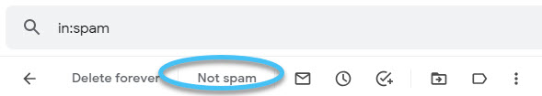 |  |  | To allow future emails from your child’s teacher to go right into your inbox:  - In your Google email account, choose settings (small gear at the top of your email).  - Choose “See all settings”.  - Choose “Filters and Blocked Addresses”.  - Click on “Create a new filter”.  - Enter the teachers email in the “From” section.  - Click on “Create filter”.  - Choose “Never send it to Spam” and choose “Categorize as: Primary”.  - Click on Create filter one last time. The filter has been created and the teachers’ emails should always go to your inbox.

If your email provider is (microsoft) outlook/msn/hotmail/live:
 | Check your Junk folder:  Often emails from a location that your provider is not familiar with will end up in Junk.  Move to Inbox:  If you have found the emails in your Junk folder, you can move them to your inbox by choosing “Not Junk” once you have opened that folder. See picture below.  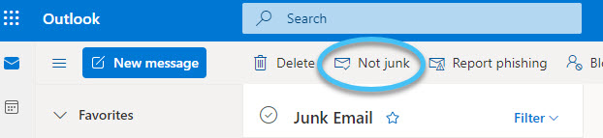 |  |  | To allow future emails from your child’s teacher to go right into your inbox:  - In your Microsoft/Outlook email account, choose settings (small gear at the top of your email).  - Click on “View all Outlook settings” found at the bottom of settings menu.  - Choose “Mail” in the first column.  - Choose “Rules” in the second column.  - Choose “Add new rule”.  - Choose “Name your rule” (this can be any name example: Not Junk).  - Add a condition, choose “From” and then type the teachers email in the box to the right of “From”.  - Add an action, choose “Move to”, choose “Inbox” in the box to the right of “Move to”.  - Click “Save”.

